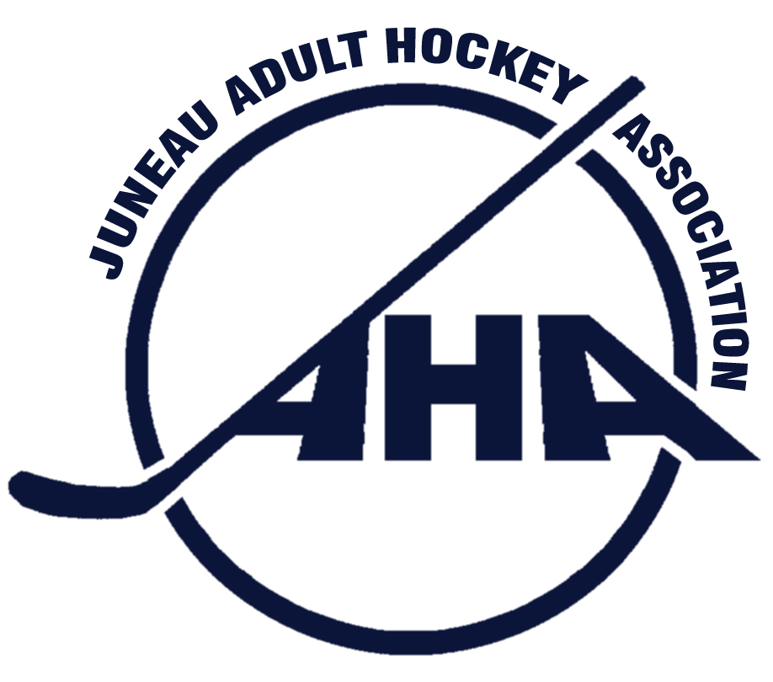

Juneau Adult Hockey Association
PO Box 21046 Juneau, Alaska 99802 * City & Borough of Juneau Tax Exempt # 582

Minutes of the Meeting of the Board of Directors of
Juneau Adult Hockey Association
Held: December 1, 2015
Meeting chair: Jason Soza
Location: Douglas Library Conference Room
Board members present:
Jason Soza, President
Michele Drummond, Secretary
Caroline Schultz, Tier B Representative
Christine Woll, Women’s Tier Representative
Joel Ozburn, Tier C Representative
Amber LaBlanc, Member at Large A
Thomas McKenzie, Registrar
Lauren Anderson (Rink Manager)
Public Present:
Julie Nielsen, Cauette Cabin Committee

Board members absent: Rick Driscoll, Vice President
Dan O’Leary, Tier A Representative
James Gamez, Member at Large B
Thomas Fletcher, Tier 40+ Reprentative

1.Call to order at 5:50 pm.

2. Standing Items
2.1 Public Comment:
Julie Nielsen, representing the Cauette Cabin Committee-
Working out the suggested donation amounts for the use of the cabin. The committee needs to decide which entity will handle the donations, JAHA or JDIA. Using the JDIA account, donations can be tax deductible since they have the proper status, JAHA does not.
Julie needs to follow up with the city on insurance for the cabin and permission for completion of the deck.

Treadwell Ice Rink Update: Lauren Anderson-
- Gear bags, these gear bags donated by USA Hockey contain the following equipment: Helmets without face shields, Jerseys, Gloves, Shin pads, Elbow pads, and Hockey Sticks.
  - The rink would like to complete these bags by acquiring Face Shields for the helmets, Hockey Pants, Shoulder pads, and Hockey Socks.
Jason Soza suggested Champions Choice in Anchorage be approached for discounted equipment.
The USA Hockey 1st Goals Program was also suggested.
- Ideas for increasing the Public accessibility for using these gear bags: Gear and bags are available for use by the public for Stick and Puck, Intro to Hockey classes, and other rink hockey activities.
  - Michele Drummond suggested lockable benches in which items could be placed, separated by gear type. Disinfectant spray should be available to treat gear upon return.
- Lauren suggested that JAHA partner with the rink to offer hockey classes.
- Rainforest Hockey Tournament is scheduled for the end of February.
- The rink staff and CBJ Building Maintenance staff are working to abate the leak in the roof. The leak is above the ice near the guest benches.

2.2 Tier Reports
Tier A: Dan O’Leary-BY EMAIL- I appreciate the patience and sportsmanship shown by the A tier players during fall season. Although players were at times frustrated with the officiating and outcomes of games it was short-lived and in the end players handled themselves with class- Thank you!
Jerseys- we were missing 4 jerseys and I have contacted players to return them. I have received two of them but there are still two more out there. I will be following up with those players. On a personal note, I will not be playing winter 2016 season (new baby due in January) but look forward to continuing as A tier representative next season and being involved in other JAHA functions.

Tier B: Caroline Schultz – No Complaints for the tier. All teams did well during the play offs.

Tier C: Joel Osburn – Teams would like to stay together, or at least keep core players for each team, when setting teams for Winter season.

Tier Women’s: Christine Woll- The women’s tier is hoping for enough players for the Winter season.

Tier 40+: Thomas Fletcher- No report, representative absent.

3. Old Business:
3.1 Proposal to amend late fee rules: Thomas Fletcher –Discussion tabled and a committee to polish the ideas and present at the next JAHA meeting was formed. Committee made up of Thomas Fletcher, Carolyn Schultz, and Jason Soza.
3.2 40+ Tier survey: Thomas Fletcher – See attached.*
3.3 JAHA Merchandise: James Gamez – The website is live and JAHA merchandise should be ordered by Dec 14, 2015 for delivery by Christmas. https://jaha2015.itemorder.com/sale

4. New Business:
4.1 Opening Registration: Thomas McKenzie-1st Sunday in September is the usual start of JAHA Fall Season, next year it will be September 4, 2016. Registration can open in May. Jason Soza proposes that the JAHA Board develop a flow chart to streamline the registration process for future boards.

4.2 Special Committees formed:
Banquet Committee: Amber LeBlanc, Michele Drummond
By Laws: Rick Driscoll
Education/Outreach: Christine Woll
Fund Raising: James Gamez
Prizes: ?

The next scheduled JAHA meeting will be January 5th 2015. Douglas Public Library meeting room.

Adjorn 7:12pm

*Thomas Fletcher Action Items:
• Changing our registration process to include a “space available” period between the initial deadline and the start of season
• Exploring options for more flexibility for Tier 40 to pick up players who are not yet 40.

Addressing the first item, our workgroup did not meet but I am providing the board with a handy table, that illustrates the process we outlined during the October board meeting. The language (“Early registration” etc) isn’t as important to me as having a mechanism to bring in players to fill tiers, before the season starts, without charging them $75.

General registration | Space Available | Late Registration
Closes Mid-August | Between General rego and Season start | After Season start
Base cost of season | $25* | $75
• Number of teams and tiers set;  • Players placed based on preference  • Games scheduled with Rink and Refs | - • Tier reps are free to fill any teams that have empty slots.  - • Teams sizes TBD  - • Players placed on teams with most need | - • Only as space allows  - • Emphasis on keeping teams intact and/or balancing teams  - • Possible exceptions to late fee:  - Replacement players  - Brand new to JAHA sign-ups

*$25 seems right to me, but perhaps some our more punitive board members will want to hike this amount up.

Onto lowering the age limit in over 40. We didn’t make a ton progress on a Tier 40 survey but I am have attaching new questions geared specifically to Tier 40 members (per Rick D’s request). They need to be word-smithed but the essential question is:

“As a Tier 40 player, would you be in favor of relaxing the age requirements for those wanting to play in our tier”.

I did ask quite a few Tier 40 players and can report UN-universal support (unfortunately!) . People were not completely opposed to lower the age limit, but wanted to make sure that any new, younger people were going to “respect the 40 tier vibe”. I have NO idea how to quantify or enforce that sentiment…but it would great if we could accommodate folks that are close to 40 and/or have spouses in the tier and are also interested in maintaining the (mostly) relaxed hockey vibe that we have going in Tier 40.

Thanks for listening,
Fletch

----Potential Qs for an Tier 40 survey-----

Question 1: For the Spring 2016, would you be in favor of one (or more ) the following rule changes for Tier 40:
a. Changing Tier 40 to Tier 35 (allowing players 35 year and older to play)
b. Allowing women of any age to play in the tier
c. Raising the age limit
d. Allowing exceptions to age limit rule on case by case basis,( for instance a spouse of an Tier 40 players or someone who is imminently turning 40)
Comments:

2. Would you be interested in a tier with the following rule changes for NEXT year (Fall 2016): –Check all that apply
a. Scoring limits (or one, two or three goals per player, a game)
b. Option to even up teams before a game (of one team is missing players or looking weak)
c. No official stats
d. A round robin tourney in place of an elimination tourney at the end of the season
3. Would you describe your current tier as (topic: general interest)
a. Too competitive
b. Not competitive enough
c. Just right
d. Other/comments

Please add or edit these questions!
Thanks,
Fletch
907.209.7131

