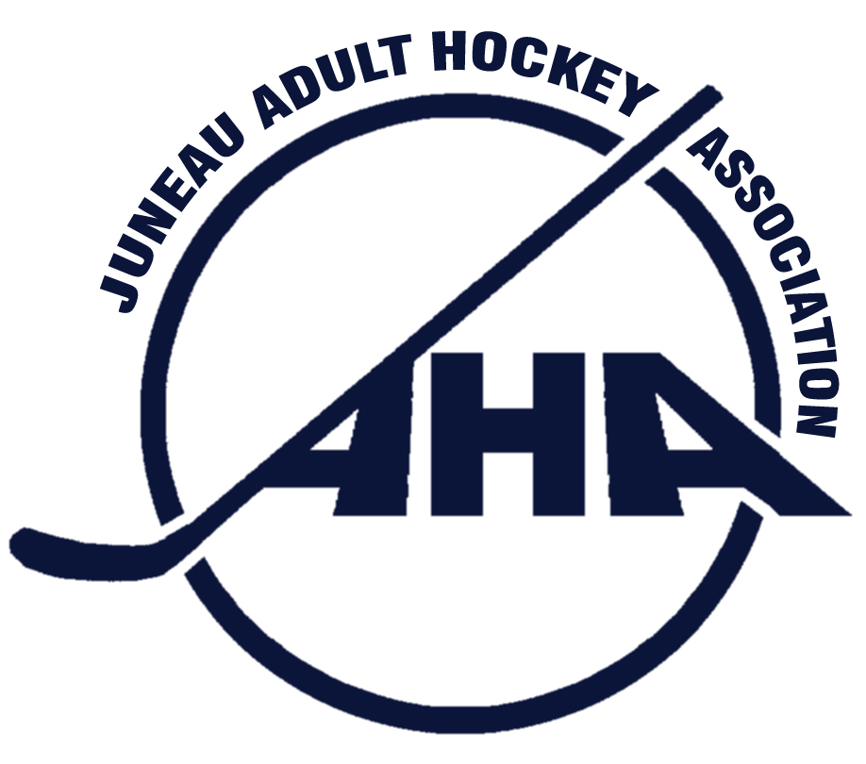

Juneau Adult Hockey Association
PO Box 21046 Juneau, Alaska 99802 * City & Borough of Juneau Tax Exempt # 582

Minutes of the Emergency Meeting of the Board of Directors of
Juneau Adult Hockey Association
Held: August 27, 2015
Meeting chair: Jason Soza
Location: Prospector Hotel Bar
Board members present: Jason Soza, President
Rick Driscoll, Vice President
Michele Drummond, Secretary
Christy Hartman, Treasurer
Thomas Fletcher, Tier 40 Representative
Christine Woll, Women’s Tier Representative
Joel Osburn, Tier C Representative
Board members absent: Amber LeBlanc, Member at Large A
Carolynn Schultz, Tier B Representative – (Comments submitted by email)
James Gamez, Member at Large B
Dan O’Leary, Tier A Representative
Thomas McKenzie, Registrar

Others present: None

Call to order at 4:49 pm and a quorum was established.

I. JAHA Late Fee Discussion- Members present discussed the pros and cons of maintaining the present fees for late registration. Also discussed were reasons that waiver of the late fee would be automatic. The consensus was that first time JAHA registrants would have the late fee waived.
A. Motion: Rick Driscoll, “change the wording, instead of a Late Fee, we have Early bird registration that runs until 10 days before the season start date.” Joel Osburn seconds the motion. The motion passes unanimously.
B. Motion: Joel Osburn, “waive all goalie late fees.” Seconded by (Blank), the motion passes unanimously.
C. The board collectively decided to open registration for the following season immediately after the full membership meeting post, Winter 2016, if this is possible with our Registrar and USA Hockey.

Meeting adjourns 5:35pm

